A Beginner's Guide to Autonomous Robots

Overview
Welcome to this introductory course where we’ll cover an overview of autonomous robots, robotic systems and architecture. Then, we’ll go through a high-level architecture of the autonomy software, starting with the traditional methods, including sensing and perception, mapping, localization, navigation, and control, as well as current trends and future directions in robotics technology.
In this course, we will:
- Identify the key components and types of autonomous robots.
- Describe the basic principles of embodied AI in robotics.
- Recognize the main elements of robotic systems and architecture.
- List the primary sensors and perception techniques used in robotics.
- Outline the fundamental concepts of localization and mapping in autonomous navigation.
- Recall the basic principles of control systems in robotics.
- Identify current trends and challenges in robotics, including the use of foundation models.
First, let’s kick off this content with an overview of autonomous robots.

Fundamentals of Autonomous Robots

Overview
In this module, Fundamentals of Autonomous Robots, we’ll explore the core concepts driving the field of robotics. From understanding the diverse applications of autonomous robots across industries to grasping the essential principles of embodied AI, this module will provide you with a solid grounding in robotics fundamentals.
By the end of this module, you’ll be able to:
- Identify various types of autonomous robots used in different industries
- Describe the basic concept of embodied AI in robotics
- List the key components of the perception-cognition-action loop in robotics
- Recall the importance of human-robot interaction in modern robotics applications
These objectives will guide you through the key aspects of autonomous robotics, helping you understand how robots perceive, think, and act in their environments. Whether you’re interested in industrial automation, healthcare robotics, or cutting-edge research in AI, this module will equip you with the knowledge to appreciate the complexities and potential of autonomous robotic systems.
As we progress through the lessons, you’ll gain insights into the interdisciplinary nature of robotics, combining elements of computer science, engineering, and cognitive science. Get ready to embark on an exciting journey into the world of autonomous robots.

Autonomous Robots
There are many types of autonomous robots, including underwater robots, drones, robotaxi, home robots, rescue robots, quadcopters, quadrupeds, humanoids, exoskeletons and manipulators.
Robots are used over all kinds of industries, including manufacturing, healthcare, agriculture, logistics, transportation, exploration, home use, retail, education, public safety, and entertainment. As you can see, nearly every market can be affected by robotics, so from a high level, what is robotics, and how do robotics work?

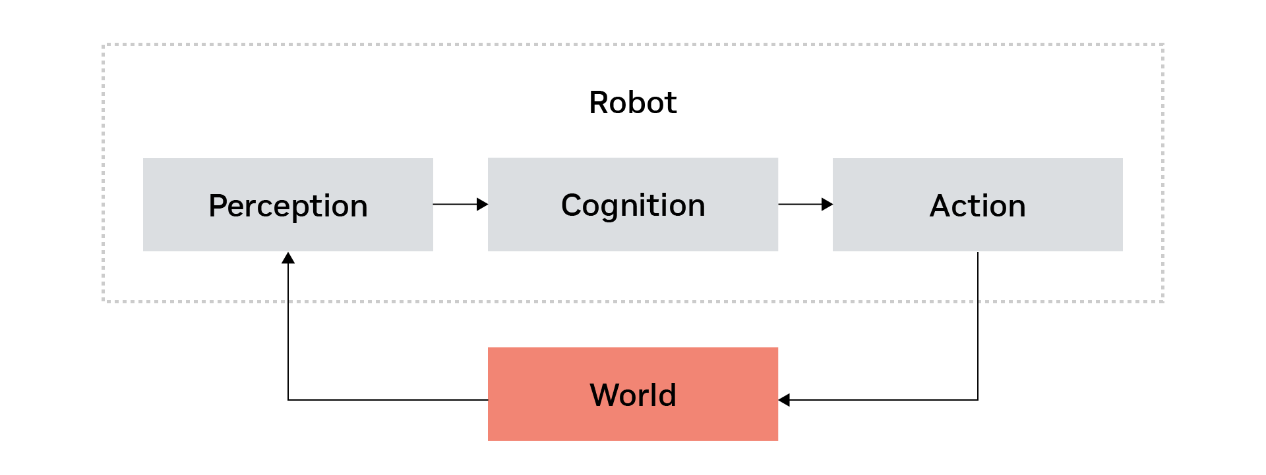

This diagram gives us an overview of embodied AI. If you think about how a robot works, it’s very similar to how a human works. We use our eyes to do the perception, our brain to do the cognition, and all of our actuators – our hands and legs – to do the action. This is how humans, and robots, interact with the world.
Perception receives what is happening in the world, that output is sent to the cognition, or the brain of the robot, and then the robot takes actions to interact with the world.

Embodied AI
Embodied AI, a subset of physical AI, represents a significant leap forward in robotics and artificial intelligence, and enables robots to interact with the physical world in increasingly sophisticated ways.

Autonomous Navigation
One of the primary abilities of embodied AI is autonomous navigation. This allows robots to move independently through various environments, making decisions about their path and avoiding obstacles without human intervention.

Object Manipulation
Object manipulation is another critical aspect of embodied AI, which includes:
- Grasping: The ability to securely hold objects of different shapes and sizes
- Complex manipulation: performing intricate tasks, such as assembling components or folding clothes.
These skills enable robots to interact with their environment in ways that closely mimic human capabilities.

Human-Robot Interaction
Recent advancements in AI have revolutionized how robots interact with humans. This includes:
- Natural language processing: Enabling communication between humans and robots using spoken or written language.
- Collaboration: Allowing robots to work alongside humans in various shared tasks, from manufacturing to healthcare facilities.
The advent of large language models has further enhanced human-robot interaction. These models have significantly improved the ability of robots to understand and respond to complex commands and queries, making interactions more natural and intuitive.

Review
Congratulations on completing the Fundamentals of Autonomous Robots module! In this foundational section, we explored the core concepts that drive the exciting field of robotics. Let’s recap what we’ve learned.
In this module, we:
- Identified various types of autonomous robots used in different industries. From manufacturing and healthcare to agriculture and space exploration, autonomous robots are changing every industry.
- Described the basic concept of embodied AI in robotics. We now understand how robots perceive, think and act in their environments.
- Listed the key components of the perception-cognition-action loop in robotics.
- Recalled the importance of human-robot interaction in modern robotics applications. Advancements in natural language processing and collaboration are enhancing the way we interact with robots.
These objectives have provided you with a solid grounding in robotics fundamentals. You now have a better understanding of how robots operate across various industries and how they interact with their environments.
We’ve explored the interdisciplinary nature of robotics, combining elements of computer science, engineering, and cognitive science. This knowledge will serve as a foundation as we delve deeper into robotic systems and architectures in the upcoming modules.
As we progress through the course, we’ll build on these concepts to explore more advanced topics in autonomous robotics. Get ready to dive into the intricacies of robotic systems and software architectures in our next module.

Robotic Systems and Architecture

Overview
In this module, Robotic Systems and Architecture, we’ll dive into the fundamental components that make up robotic systems and explore how they work together to create functional autonomous robots. We’ll examine the intricate relationship between hardware and software in robotics, and learn about the key elements of robotic architecture.
By the end of this module, you’ll be able to:
- Identify the main components of robotic systems, including hardware and software elements.
- Describe the process of robotics integration and its importance in creating cohesive systems.
- Recognize the role of simulation and testing in robotics development.
- Outline the basic structure of autonomy software architecture.
- Explain the functions of key hardware components such as sensors, actuators, and controllers.
As we progress through the lessons, we’ll explore both the hardware and software aspects of robotics, giving you a comprehensive view of how these complex systems come together. Get ready to uncover the inner workings of robotic systems and gain a deeper appreciation for the engineering behind autonomous robots.

Robotics Integration
The core of robotic systems lies in the seamless collaboration of hardware and software components. This integration process involves:
- Hardware components: Sensors, actuators, and other physical parts that enable the robot to interact with its environment.
- Software systems: Programs and algorithms that control the robot’s behavior and decision-making process.
The goal is to create a cohesive system where all the parts work together, enabling complex operations and communication within the robot.

Simulation and Testing
Simulated environments, such as NVIDIA Isaac Sim, NVIDIA Isaac Lab, or Gazebo, help us validate the whole system before deploying robots in real-world scenarios. We can also leverage various testing frameworks, such as hardware-in-the-loop (HIL) testing, software-in-the-loop (SIL) testing as well as unit testing or system-level testing.

Development Frameworks
Robotics development often relies on specialized platforms and frameworks. One notable example is ROS (Robot Operating System), which provides a flexible framework for writing robot software. Other middleware operating systems can also be used.

Hardware Integration
The goal for hardware integration is to combine various hardware components to function seamlessly as a cohesive system, in order to ensure reliable and efficient interaction between sensors, actuators and controllers.

Sensors
Sensors are vital for environmental perception, navigation assistance, and providing feedback for control systems. Common types include:
- Cameras: For visual input
- LIDAR: For distance measurement
- IMU (Inertial Measurement Unit): For orientation
- GPS: For location tracking

Actuators
Actuators enable movement and manipulation, applying force and making adjustments based on sensor feedback. Types of actuators include:
- Motors: DC and stepper motors for movement
- Servos: For precise position control
- Pneumatic and Hydraulic Actuators: For force application

Controllers
Controllers process sensor data, execute control algorithms, and facilitate communication among components. Examples include:
- Microcontrollers: Such as Arduino and PIC
- Single-board Computers: Like Raspberry Pi and NVIDIA Jetson
- Embedded Systems: For integrated control solutions

The integration process involves ensuring that all hardware components work together efficiently for reliable operation across the entire robotic system and efficient data processing for real-time decision making. By focusing on these aspects, hardware integration enables robots to perform complex tasks with precision and adaptability.

Autonomy Software Architecture

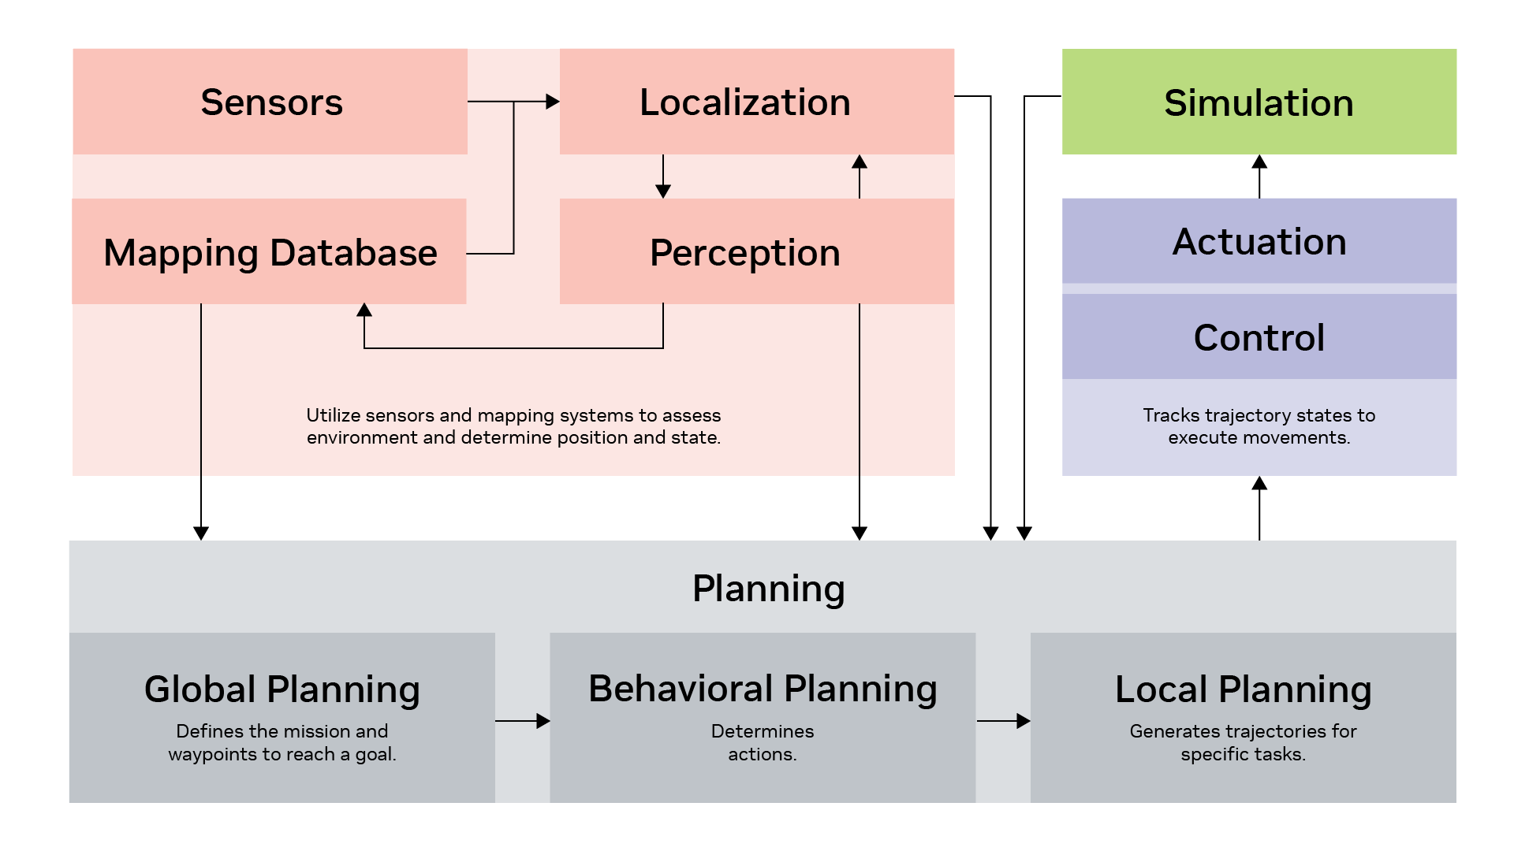

This diagram provides an overview of a relatively complex autonomy software architecture, often used in applications like robotaxis. It illustrates the integration of various components essential for autonomous systems, though some robots may only use a subset of these elements.
- Perception and Localization: Utilizes sensors such as cameras and LIDAR, along with mapping systems, to assess the environment and determine the robot’s position and state.
- Planning: Involves multiple stages:
  - Global Planning: Similar to setting a route on a map, defining the mission and waypoints to reach a goal.
  - Behavior Planning: Determines actions, such as which object to manipulate and how.
  - Local Planning: Generates trajectories for specific tasks, guiding the robot through precise paths.
- Control and Actuation: The controller tracks trajectory states to execute movements, whether for manipulation or navigation. Outcomes are tested in both virtual simulations and real-world scenarios.
- Feedback Loop: Continuously gathers data from sensors and localization to refine planning and improve system performance. This iterative process ensures adaptive and responsive robot behavior.

Review
Congratulations, we’ve completed the Robotic Systems and Architecture module. Let’s recap what we’ve learned.
In this module, we:
- Identified the main components of robotic systems, including hardware and software elements. We explored how sensors, actuators, and controllers work together to form the physical basis of robotic systems.
- Described the process of robotics integration and its importance in creating cohesive systems. We learned how hardware and software components are combined to create a functional robotic system, emphasizing the importance of seamless collaboration.
- Recognized the role of simulation and testing in robotics development. We discovered how tools like NVIDIA Isaac Sim and various testing frameworks are crucial for validating robotic systems before real-world deployment.
- Outlined the basic structure of autonomy software architecture. We examined the key components of autonomy software, including perception, planning, and control, and how they interact to enable autonomous behavior.
- Explained the functions of key hardware components such as sensors, actuators, and controllers. We delved into specific examples of each, understanding their roles in enabling robots to perceive their environment and interact with it effectively.
This module has provided you with a solid foundation for understanding how robotic systems are built and integrated. You now have insights into both the hardware and software aspects of robotics, giving you a comprehensive view of how these complex systems come together.
As we move forward, we’ll build on this knowledge to explore more advanced topics in autonomous robotics. The next module will focus on how robots understand and interact with their environment, applying the architectural concepts we’ve learned here.

Enabling Autonomous Robots to Understand Their Environment

Overview
In this module, Enabling Autonomous Robots to Understand Their Environment, we’ll explore the fundamental technologies and processes that allow robots to perceive, interpret, and interact with their surroundings. Understanding how robots make sense of the world around them is key to grasping the full potential of autonomous systems.
By the end of this module, you’ll be able to:
- Identify various types of sensors used in robotics and their specific applications.
- Describe the process of perception and sensor fusion in robotic systems.
- Explain the concepts of localization and mapping in autonomous navigation.
- Outline the basics of robot navigation and path planning.
- Recognize the role of control systems in executing robotic movements.
We’ll delve into the ecosystem of robotic sensing, from cameras and LiDAR to more specialized sensors. You’ll learn how robots combine data from multiple sources to build a comprehensive understanding of their environment. We’ll also explore the challenges and solutions in robot localization, mapping, and navigation - essential skills for any autonomous system.
This module forms the bridge between understanding robotic architecture and appreciating the advanced capabilities of modern autonomous robots. Whether you’re interested in developing robotic systems, working with autonomous vehicles, or simply fascinated by how robots “think,” this module will provide you with valuable insights into the core technologies enabling robot autonomy.

Sensing
Sensing is crucial for enabling autonomous robots to understand their environment. This overview explores the different types of cameras and sensors used in robotics, highlighting their unique advantages and applications.

Types of Cameras
- Monocular Cameras: Single-lens cameras that capture 2D images. They are simple, cost-effective, and widely available, making them ideal for basic object detection, image recognition, and simple navigation tasks.
- Stereo Cameras: Use two lenses to capture images simultaneously, mimicking human binocular vision. This setup provides depth perception and 3D information, useful for obstacle avoidance and 3D mapping. An example is the Hawk 3D depth camera.
- RGB-D Cameras: Combine standard RGB color imaging with depth sensing to provide robust 3D perception. These cameras are beneficial for advanced navigation, object manipulation, and interaction. The Intel RealSense stereo RGB-D camera is a popular choice.
- Thermal Cameras: Detect infrared radiation to create images based on temperature differences. They are effective in dark environments or through smoke and fog, making them valuable for search, rescue, and surveillance operations.
- Event-Based Cameras: Offer high temporal resolution and low latency, ideal for high-speed motion detection and tracking.
Understanding these camera types helps in selecting the right sensor for specific robotic applications, enhancing the robot’s ability to perceive and interact with its surroundings effectively.

Types of Lidar
- 2D Lidar: Simpler, cheaper, and faster, but with limited functionality. Ideal for basic planar navigation and obstacle detection.
- 3D Lidar: Provides detailed spatial information, a wide field of view, and high resolution, making it suitable for autonomous vehicle mapping. However, it is generally more expensive than cameras.
- Solid-State, Flash, and MEMS Lidar: Offer durability and cost-effectiveness, using laser pulses to measure distances and create detailed maps.

Perception
In the world of robotics, perception is crucial for enabling autonomous robots to understand their environment. Just as humans use a combination of senses like sight, hearing, and touch to interpret the world around them, robots rely on sensor fusion. This process integrates data from multiple sensors to create a comprehensive and accurate representation of the environment.

Key Components of Perception
- Sensor Fusion: Combines data from various sensors to provide a holistic view of the surroundings.
- Object Detection and Recognition: Identifies and classifies objects within the robot’s environment.
- Object Tracking: Continuously follows an object as it moves, similar to how our eyes track moving objects.
- Scene Understanding: Interprets the overall context of the environment, allowing robots to make informed decisions.

Isaac Perceptor

Perception
In the world of robotics, perception is crucial for enabling autonomous robots to understand their environment. Just as humans use a combination of senses like sight, hearing, and touch to interpret the world around them, robots rely on sensor fusion. This process integrates data from multiple sensors to create a comprehensive and accurate representation of the environment.

Key Components of Perception
- Sensor Fusion: Combines data from various sensors to provide a holistic view of the surroundings.
- Object Detection and Recognition: Identifies and classifies objects within the robot’s environment.
- Object Tracking: Continuously follows an object as it moves, similar to how our eyes track moving objects.
- Scene Understanding: Interprets the overall context of the environment, allowing robots to make informed decisions.

Isaac Perceptor

NVIDIA has developed Isaac Perceptor, a camera-based 3D perception system designed for mobile robots. This system offers:
- Robust Odometry: Tracks the robot’s movement through its environment, akin to how we gauge our position while walking.
- Local 3D Scene Reconstruction: Builds a three-dimensional map of the surroundings to aid in autonomous navigation.
The Isaac Perceptor leverages technologies like VSLAM (Visual Simultaneous Localization and Mapping) for accurate odometry and NVBlox for detailed 3D reconstruction. This integration is essential for developing advanced navigation applications in robotics, paving the way for future innovations in human-like robotic vision systems.

NVIDIA has developed Isaac Perceptor, a camera-based 3D perception system designed for mobile robots. This system offers:
- Robust Odometry: Tracks the robot’s movement through its environment, akin to how we gauge our position while walking.
- Local 3D Scene Reconstruction: Builds a three-dimensional map of the surroundings to aid in autonomous navigation.
The Isaac Perceptor leverages technologies like VSLAM (Visual Simultaneous Localization and Mapping) for accurate odometry and NVBlox for detailed 3D reconstruction. This integration is essential for developing advanced navigation applications in robotics, paving the way for future innovations in human-like robotic vision systems.

Localization and Mapping
Localization and mapping are essential for robots to navigate and interact with their environment effectively. Imagine a robot as a traveler who needs a map and a compass to explore unfamiliar territory. These processes enable the robot to determine its position and create a map of its surroundings.

The Importance of Localization
Localization helps robots identify their position within an environment, allowing them to make informed decisions. For instance, in tasks like trajectory tracking, knowing the exact location is crucial to ensure the robot follows the intended path accurately.
- GPS (Global Positioning System): Used primarily outdoors to provide location data.
- Visual Odometry: Utilizes camera images to estimate movement, turning the task into a computational problem.
- Lidar-Based Localization: Matches current positions with pre-existing maps using laser-based sensors.

Mapping Techniques
Mapping involves creating a representation of the environment, which is vital in large spaces like warehouses or factories.
- SLAM (Simultaneous Localization and Mapping): A technique where robots simultaneously build a map and track their location within it.
- Occupancy Grids: Represent environments as grids, with each cell indicating the probability of being occupied.
Navigation and Path Planning
In autonomous mobile robotics, navigation and path planning are important to ensure that robots can move efficiently and safely through their environments. This involves several layers of planning, each with a specific focus.

Classical Navigation Systems

Routing and Mission Planning
Routing and mission planning determines the preferred route over map networks. It commonly uses algorithms including A*, D*, and RRT (Rapidly-exploring Random Tree). This is similar to getting directions at an intersection—deciding whether to go straight or turn.
This typically isn’t enough on its own, so we need additional layers of planning. That’s why we bring in motion planning.

Motion Planning
Motion planning generates a sequence of movements that allow robots to follow a planned path while avoiding obstacles. It usually takes a few seconds to process both components, decision making and trajectory generation.
- Decision Making: Focuses on behavior planning and interactions, such as deciding whether to navigate around obstacles like pallets or yield to moving forklifts.
- Trajectory Generation: Involves creating a time-based trajectory, detailing speed, acceleration, and heading angles for precise control.

Obstacle Avoidance
- Real-Time Detection: Ensures functional safety by detecting and avoiding obstacles in real time.
- Reactive Navigation: Uses sensors to make immediate adjustments, acting as a backup when the main autonomy system fails to detect obstacles.

Control Systems in Robotics
Once a robot’s trajectory and target states are defined, the control system translates this information into commands for the robot’s actuators. This ensures that the robot follows the planned path accurately.

Feedback Control
Feedback controls adjust the robot’s actions based on sensor input to achieve desired behaviors.
A common method for feedback control is PID control (Proportional-Integral-Derivative). PID control is a widely used algorithm that minimizes the error between desired and actual positions by continuously adjusting movements. It operates by comparing the desired trajectory states with actual states obtained from localization data and making real-time corrections.

Trajectory Tracking
You can use trajectory tracking to ensure the robot accurately follows a planned trajectory.
One commonly used method is MPC (Model Predictive Control). MPC is an advanced control strategy that optimizes the robot’s path using a predictive model of its behavior. MPC is more sophisticated than PID control and is often used for precise trajectory tracking and whole-body control in humanoid robots.
These control methods are essential for ensuring that robots can navigate their environments effectively, maintaining accuracy and safety in their movements.
Review
Congratulations on completing this module, Enabling Autonomous Robots to Understand Their Environment. Let’s recap what we’ve learned.
In this module, we:
- Identified various types of sensors used in robotics and their specific applications. We explored different camera types, LiDAR systems, and other sensors like ultrasonic and IMUs, understanding how each contributes to a robot’s perception of its environment.
- Described the process of perception and sensor fusion in robotic systems. We learned how robots combine data from multiple sensors to create a comprehensive understanding of their surroundings, much like how humans use multiple senses to interpret the world.
- Explained the concepts of localization and mapping in autonomous navigation. We discovered how techniques like SLAM enable robots to simultaneously build maps of their environment and track their position within it, essential for effective navigation.
- Outlined the basics of robot navigation and path planning. We examined different layers of planning, from high-level routing to real-time obstacle avoidance, understanding how robots make decisions to move efficiently and safely.
- Recognized the role of control systems in executing robotic movements. We explored feedback control methods like PID and MPC, learning how these systems ensure robots accurately follow planned trajectories and respond to their environment.
This module has provided you with a comprehensive understanding of how robots perceive, navigate, and interact with their environment. You now have insights into the complex systems that enable robots to function autonomously, from the sensors that act as their “eyes and ears” to the control systems that guide their movements.
As we move forward, we’ll build on this knowledge to explore current trends and future directions in robotics. The next module will focus on how advanced technologies like foundation models are shaping the future of autonomous robots, applying the fundamental concepts we’ve learned here to cutting-edge applications.

Current Trends and Future Directions in Robotics

Overview
Welcome to the final module of our course, Current Trends and Future Directions of Robotics. In this module, we’ll explore the developments that are shaping the future of robotics. As the field evolves, it’s important to understand the emerging technologies and approaches that are pushing the boundaries of what robots can do.
By the end of this module, you’ll be able to:
- Identify key trends in robotics, including the integration of artificial intelligence and machine learning.
- Describe the concept and potential applications of foundation models in robotics
- Recognize the growing importance of human-robot collaboration and its impact on various industries.
- Explain the role of advanced technologies like digital twins in optimizing robotic systems.
- Outline the challenges and opportunities in the development of humanoid robots.
This module will provide you with insights into the current directions in robotics research and development. Whether you’re interested in industrial automation, healthcare robotics, or the potential of AI-driven robots, this module will give you a comprehensive overview of where the field is headed.

Robotics Tasks Leveraging Foundation Models
Foundation models are transforming robotics by enhancing capabilities in perception, decision-making, and control. These models, pre-trained on vast datasets, offer superior adaptability and generalization compared to traditional methods.

Key Areas of Application
- Robot Policy Learning: Techniques like diffusion policies, language-conditioned imitation learning, and reinforcement learning improve data efficiency and contextual understanding. These models help robots learn optimal actions through language-driven rewards.
- Value Learning: Instead of directly learning policies, robots learn value functions to choose actions with the lowest cost, enhancing decision-making processes.
- High-Level Task Planning: Foundation models enable cognitive-level planning for complex tasks. For example, humanoid robots can understand high-level instructions like picking up a specific box by leveraging these models.
- LLM-Based Code Generation: Large language models (LLMs) generate code for robot training and execution. This capability is exemplified by systems like GenSim, which create task simulations for various applications.

Advanced Techniques
- Open Vocabulary Object Detection and 3D Classification: Models like Dino V2 enhance encoding capabilities for diverse objects without predefined categories, crucial for dynamic environments.
- Semantic Segmentation: Open-vocabulary segmentation allows robots to recognize and interact with previously unseen objects, expanding their operational scope.
- 3D Representation and Affordance: Foundation models offer open-vocabulary 3D representations, enabling robots to infer object affordances—deciding how to interact with objects based on their properties.

Physical AI and Simulation
Physical AI (or embodied AI) systems like Voyager and MineDojo simulate tasks to train robots in both virtual and real-world settings. These systems leverage foundation models to improve task execution and adaptability.
Foundation models are paving the way for more intelligent and versatile robotic systems, capable of performing complex tasks with minimal human intervention.
Next, we’ll discuss examples of foundation models being developed at NVIDIA.

NVIDIA Cosmos

NVIDIA Cosmos is a world foundation model designed to accelerate the development of physical AI systems, including robots and autonomous vehicles. Cosmos introduces a family of world foundation models (WFMs) that are purpose-built for generating physics-aware videos and world states.
World foundation models are neural networks that can predict and generate physics-aware virtual environments. These models are trained on vast amounts of data. Cosmos WFMs offer developers an efficient way to generate massive amounts of photoreal, physics-based synthetic data. This capability significantly reduces the time and cost associated with training and evaluating physical AI models.
NVIDIA Cosmos represents a significant leap forward in physical AI and robotics development. By providing powerful world foundation models and tools, it promises to accelerate innovation in autonomous vehicles, robotics, and other physical AI applications, potentially ushering in a new era of intelligent machines.

Mobility Foundation Model

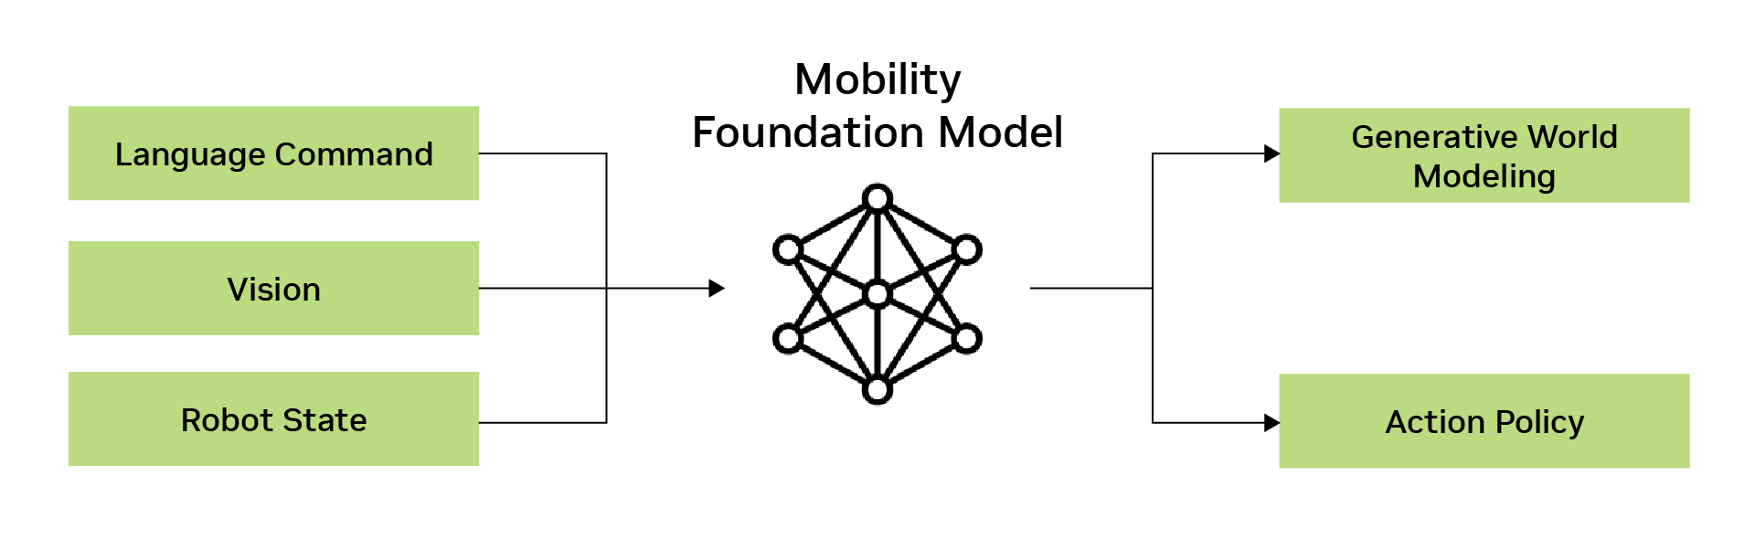
The Mobility Foundation Model acts as a central “brain” for robotic systems, processing robust vision states and generating word modeling and action policies. This model is designed to work across various robotic embodiments, including Autonomous Mobile Robots (AMRs).

Key Features
- Simulation-Based Training: The model is trained using only simulation data, allowing for efficient development without physical trials.
- Zero-Shot Deployment: Successfully deployed in real-world environments like the Hubble Lab without additional training, demonstrating its adaptability.
- Cross-Embodiment Capability: Policies developed for AMRs are transferable to other robots, such as humanoid robots, quadrupeds, and space forklifts.
This model exemplifies the potential for cross-platform functionality in robotics, addressing complex computational challenges and paving the way for versatile applications

VLM, LLM and RAG for Robotics

The integration of Vision Language Models (VLM), Large Language Models (LLM), and Retrieval-Augmented Generation (RAG) is transforming robotics through a concept known as incidental perception. This approach allows robots to build and utilize memory to navigate and interact with their environment effectively.

Key Features
- Memory Building: Robots use these models to remember events, locations, and times, enabling them to return to specific places when needed.
- Demo Example: In a recent NVIDIA office demo, a robot was instructed to find a “nice view.” It recalled previous observations, such as greenery, and guided the user to that location.
- Task Execution: The robot can perform tasks like fetching items based on memory. For instance, it can locate chips in a kitchen by remembering where they were previously seen.

Technology Components
- Video Language Model (VLA): Captures and captions video data every few seconds, storing this information in a vector database for long-term memory.
- Speech Processing: Utilizes NVIDIA’s Vsper for converting speech into text, enhancing interaction capabilities.
- Open Vocabulary Learning: Allows the robot to understand and respond to new and diverse queries without predefined categories.
This integration of VLM, LLM, and RAG enables robots to have extended memory and improved interaction capabilities, paving the way for more intuitive and responsive robotic systems.

Open Challenges in Robotics
While foundation models offer significant advancements, several challenges remain in robotics.

Key Challenges
- Data Scarcity: Training models require vast amounts of data, which is often limited in robotics. NVIDIA’s tools like Isaac Sim and Isaac Lab help address this by simulating environments to generate data.
- Real-Time Performance: Deploying foundation models in real-time is crucial. Technologies like NVIDIA’s Orin enable on-device processing, reducing reliance on cloud computing and enhancing performance.
- General Purpose Perception: Achieving a truly general perception system that can handle diverse tasks and environments remains challenging.
- Unified Representation: Integrating multi-modal inputs (e.g., visual, auditory) into a cohesive understanding is complex but essential for robust robot behavior.
- Robustness and Safety: Evaluating and ensuring the safety and reliability of robots in unpredictable situations is vital. Tools like OSMO (software-in-the-loop and hardware-in-the-loop) aid in this evaluation process.

Opportunities
- On-Edge Deployment: Running models directly on devices enhances performance and reduces cloud dependency, as demonstrated by NVIDIA’s VLA demo.
- Benchmark Development: Creating benchmarks helps compare algorithms across scenarios, improving reproducibility and performance assessment.
- Human-Robot Interaction: Enhancing social navigation and understanding human expectations improves collaboration between humans and robots.

Review
Congratulations, we’ve completed the last module in this course, Current Trends and Future Directions of Robotics! Let’s recap what we’ve learned.
In this module, we:
- Identified key trends in robotics, including the integration of artificial intelligence and machine learning. We explored how foundation models are transforming robotics by enhancing capabilities in perception, decision-making, and control across various applications.
- Described the concept and potential applications of foundation models in robotics. We learned about the Mobility Foundation Model and its ability to work across different robotic embodiments, demonstrating the power of simulation-based training and zero-shot deployment.
- Recognized the growing importance of human-robot collaboration and its impact on various industries. We examined how the integration of Vision Language Models (VLM), Large Language Models (LLM), and Retrieval-Augmented Generation (RAG) is enabling more intuitive and responsive robotic systems.
- Explained the role of advanced technologies like digital twins in optimizing robotic systems. We discovered how simulation tools like NVIDIA’s Isaac Sim and Isaac Lab are helping address challenges in data scarcity and system evaluation.
- Outlined the challenges and opportunities in the development of humanoid robots. We discussed open challenges such as real-time performance, general-purpose perception, and the need for robust safety measures, as well as opportunities in on-edge deployment and improved human-robot interaction.
This module has provided you with insights into the developments shaping the future of robotics. You now have a comprehensive understanding of how emerging technologies are pushing the boundaries of what robots can do, from enhancing their cognitive abilities to improving their interaction with humans and the environment.
As we conclude this course, consider how these advancements might influence various industries and potentially your own work or interests in the field of robotics. The future of robotics is bright, and the knowledge you’ve gained here will help you navigate and contribute to this exciting and rapidly evolving field.

Review: A Beginner's Guide to Autonomous Robots
Congratulations on completing this course, A Beginner's Guide to Autonomous Robots! Let’s recap what we’ve learned throughout this journey.
In this course, we:
- Identified various types of autonomous robots used in different industries. We explored robots in manufacturing, healthcare, agriculture, logistics, and many other sectors, understanding their diverse applications and impacts.
- Described the basic concept of embodied AI in robotics. We learned how robots, like humans, use perception, cognition, and action to interact with their environment, forming the foundation of embodied AI.
- Recognized the main elements of robotic systems and architecture. We examined the integration of hardware and software components, understanding how sensors, actuators, and controllers work together to create functional robotic systems.
- Listed the primary sensors and perception techniques used in robotics. We explored various types of cameras, LiDAR, and other sensors, as well as perception techniques like sensor fusion and object detection.
- Outlined the fundamental concepts of localization and mapping in autonomous navigation. We delved into techniques like SLAM (Simultaneous Localization and Mapping) and understood their importance in enabling robots to navigate their environments effectively.
- Recalled the basic principles of control systems in robotics. We learned about feedback control methods like PID and MPC, understanding how they ensure robots follow planned trajectories accurately.
- Identified current trends and challenges in robotics, including the use of foundation models. We explored how foundation models are transforming robotics, enhancing capabilities in perception, decision-making, and control, while also discussing open challenges like data scarcity and real-time performance.
This course has provided a comprehensive introduction to the world of autonomous robotics. From understanding the basics of robotic systems to exploring cutting-edge developments in AI and robotics, you now have a solid foundation to appreciate and engage with this rapidly evolving field.
As robotics continues to advance and integrate into various aspects of our lives, the knowledge you’ve gained here will be invaluable in understanding and potentially contributing to these exciting developments.

